EDA and insights:

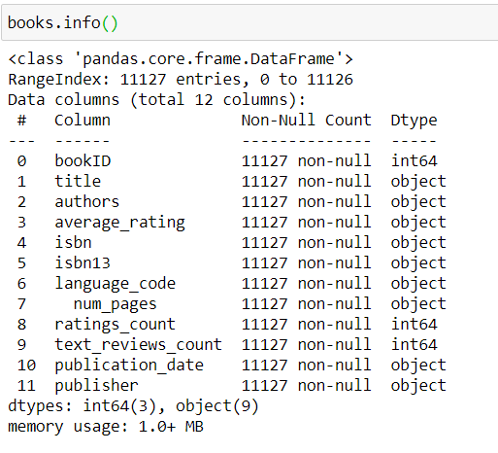

* We can see that there are no missing values in the dataset. Also there are no duplicate values.

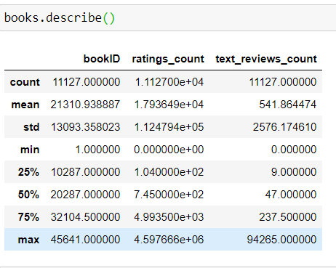

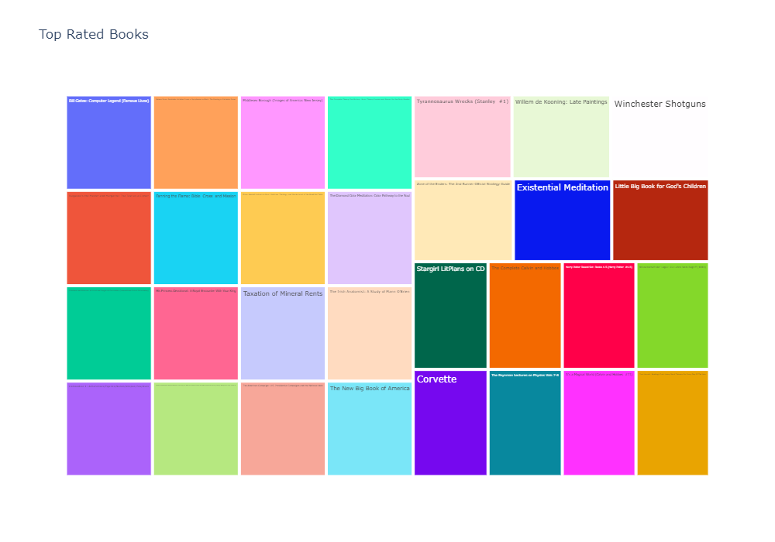

* We can see that most of the scientific, life hack and art related books have min rating of 4.8

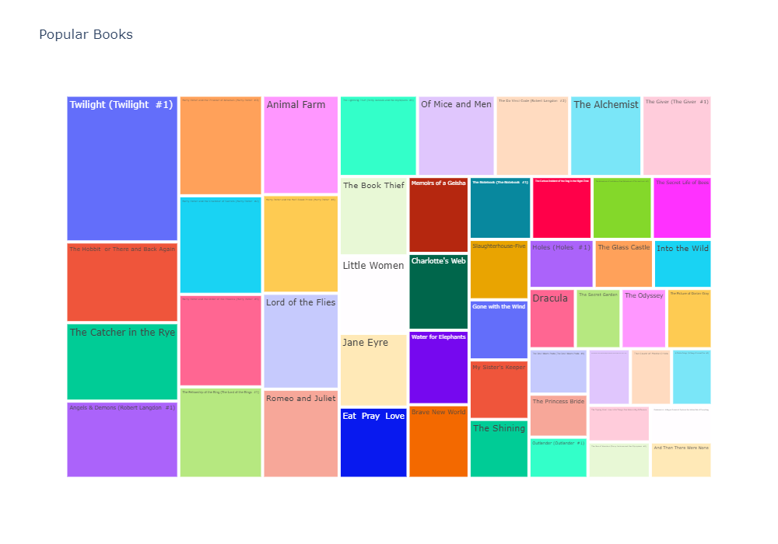

* Most of the fantasy, love, and adventures books are more likely to be famous than others.

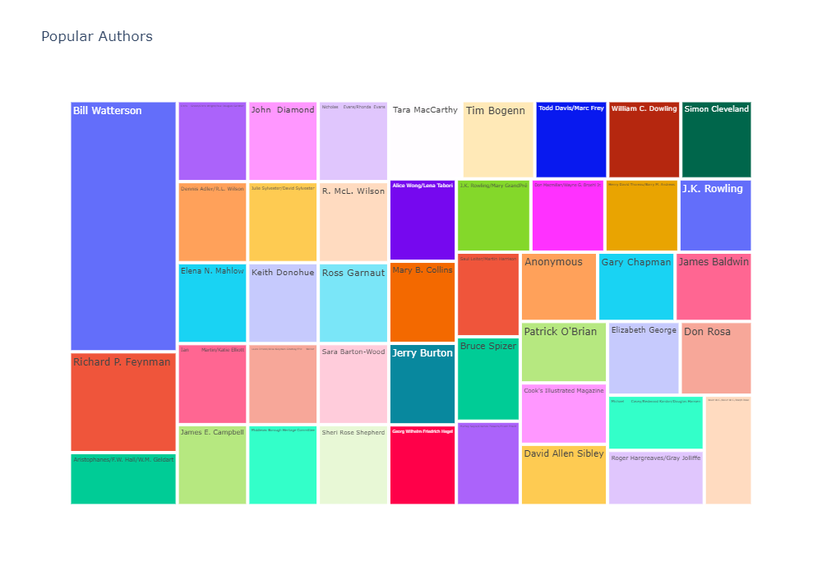

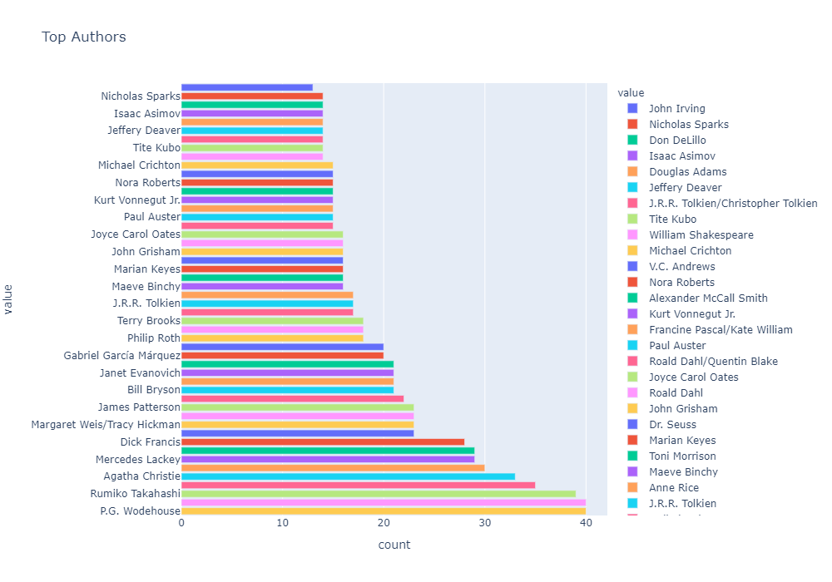

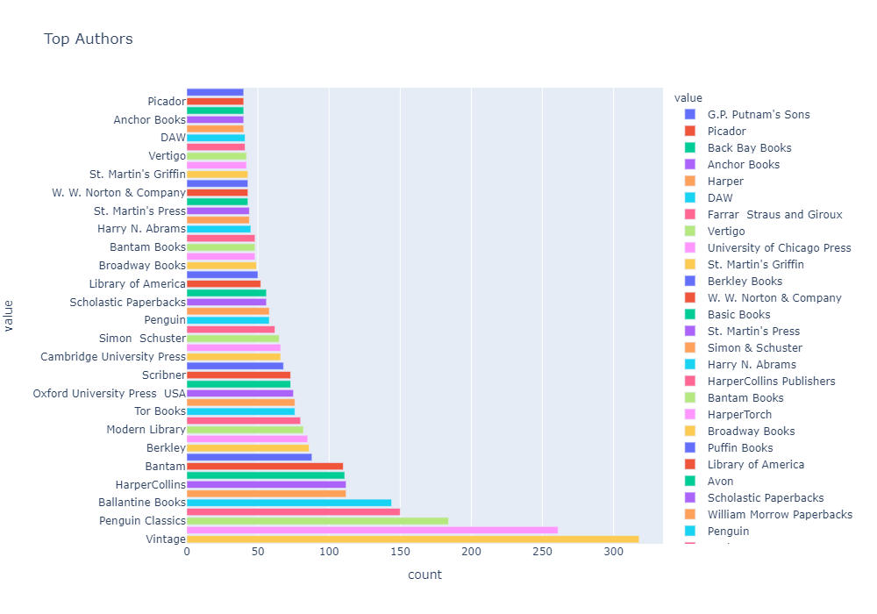

* Bill Watterson is more popular author than others. Second will be Richard P. Feynman.
* P.G. Wodehouse and Stephen King wrote more books when compare to others.
* Vintage published more than 300 books, Penguin books - 260 and Penguin Classics – 184.

